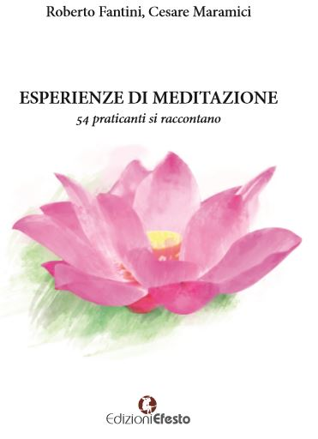
Experiences of meditation.

Following the growing interest in the meditative practices, both authors, - the first one mainly characterized by his enthusiasm for meditation (Cesare Maramici), and the other one (Roberto Fantini) guided by a detached, critical approach: two distinct, but closely complementary interpretations - have made a long journey through "meditation": 54-interviews with people who have been practicing meditation for a long time and with conviction, who told their expectations, their experiences, their impressions, the results obtained with the exercise of regular and constant meditation.
Before, meditation was an exercise reserved, in a not very distant past, to the eastern masters and to very few persons here while nowadays it is a very diffused practice.

Despite the difficulty of restoring with words such an intimate and personal feeling, so tied to the spiritual dimension, the interviews are providing a wide framework, full of ideas and of generous incentives, able in a few words to guide those who want to get on this path or simply those who want to be informed of this subject.
The interviews were made in a structured way on the basis of a questionnaire composed of 10 questions.
Respondents are very different from each other: Catholic priests, yoga teachers, Buddhist and Hindu masters, Sufi, transpersonal psychologists, atheists, theosophists, independent researchers, doctors and others.
Everyone was asked what is the value and meaning of meditation, what techniques they use, what paths they follow, whether they had a teacher or are self-taught, if meditation has had the effect of changing their lives for the better, why they started meditating. In addition everyone provided an advice to those who wish to learn meditation.

The result is a significant picture in many ways surprising, as it shows that even here in Italy meditation is becoming a well-known and appreciated practice which can promote the development of people, and make them more aware and able to face life in all its aspects, as well as more open to the transcendent world. As a matter of fact, meditation is, for those who practice it, something central within their existence, something that allows them to operate important metamorphoses, impacting significantly on how to face life and to relate to others.

The book includes a list of schools and associations to which the respondents refer, with a brief but comprehensive description of their history and purposes.

The introduction was written by Paola Giovetti who is one of the most famous expert in spirituality in Italy.
Paola concludes with these words: this book is not only a manual, but also a book full of wisdom, spirituality, life stories; a book that gives you access to a new world, in unexpected ways, which is really worth knowing.

The book ends with a citation from Krishnamurti:
"If there is no generosity, meditation is not possible; This means being free from pride, ambition to climb the ladder of success; do not pretend in any way to become famous, get rid of everything which you have been accumulating. This is the only fertile ground on which goodness can blossom and flourish.
Meditation is the flowering of goodness. " J. Krishnamurti.

All the rights of authors will go to the association Medici senza frontiere and to Ostia for Africa, an association composed of young students who are building a secondary school in Balaka (Malawi).

If you would like to buy a copy the price is 15,00 euros, you may write to the author maramicicesare4@gmail.com.

Cesare Maramici, one of the two authors is a member of the FAO Human Values Group and among the interviewees there are some persons who adhere to the HumanValues Group.
He is also teaching yoga at FAO on Thursdays at 6 p.m. (gym A).

